|  |  |  |  |  |  |  |  |  |
| --- | --- | --- | --- | --- | --- | --- | --- | --- |
| |  | | --- | | JBL Micas 2 wireless microphone | | **D:_TUMA SOUND\Audio accessories\JBL Micas 2 wireless microphone 1.1.jpg** |  |  |  |  |  | | --- | --- | --- | --- | |  | **D:_TUMA SOUND\Audio accessories\microphone-khong-day-jbl-micas-2-2.jpg** | **D:_TUMA SOUND\Audio accessories\microphone-khong-day-jbl-micas-2-3.jpg** |  | |  | **Featured information:**   * High sensitivity supports accurate sound reproduction down to every detail * Super standard sound capture for improved vocal quality * Quickly pair with a variety of current karaoke devices * Equipped with 2 mic arms and 1 mini wireless signal transceiver   **Price: 100$**  **Specifications:**   * **Frequency:** 200 frequency channels * **Range:** Operating range 40m * **Sound:** Capture sounds extremely accurately, Anti-howling, Maximum vocal support |

### **Description:**

#### **Small style:**

JBL Wireless Wireless Microphone is designed with 2 mic arms and 1 mini signal transceiver to make installation simpler and easier, optimal for family rooms with small spaces. Is a great choice.

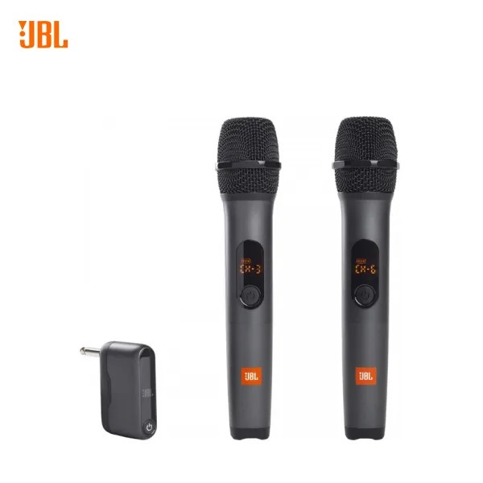

JBL wireless microphone delivers pristine sound with crystal clear vocals and incredible detail. Users can freely sing and perform high songs without fatigue and exertion. Simply plug the wireless dual-channel amplifier into your speakers, turn on the microphone, and you're ready to shine.

#### **High sensitivity**

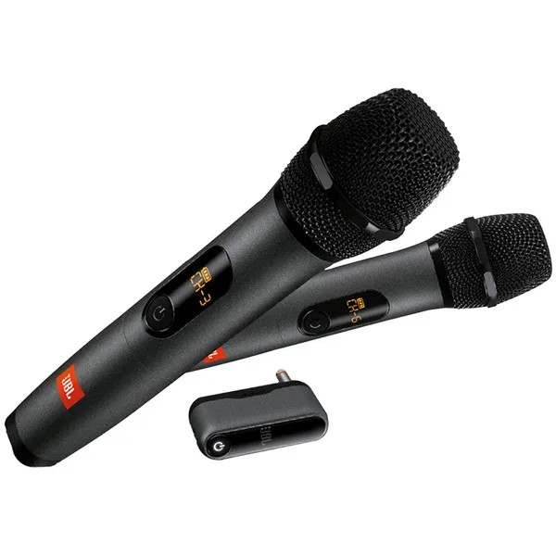

Good sound reproduction ability thanks to the company's high-end mic integrated into the product. Users can easily sing high notes without worrying about being out of breath

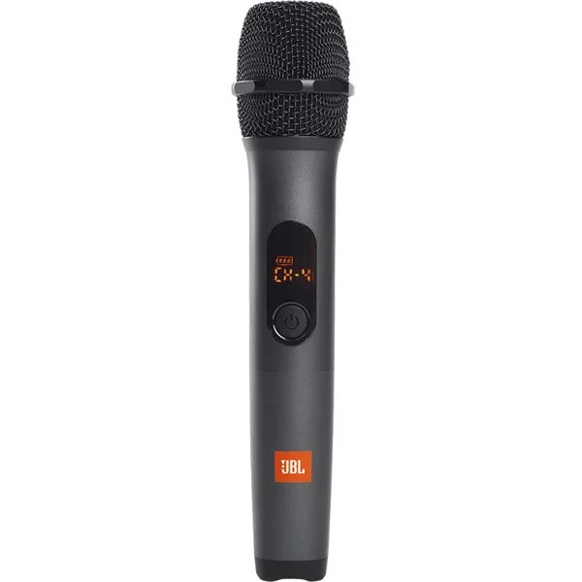

JBL Wireless Microphone combines with many portable karaoke speaker models everywhere.

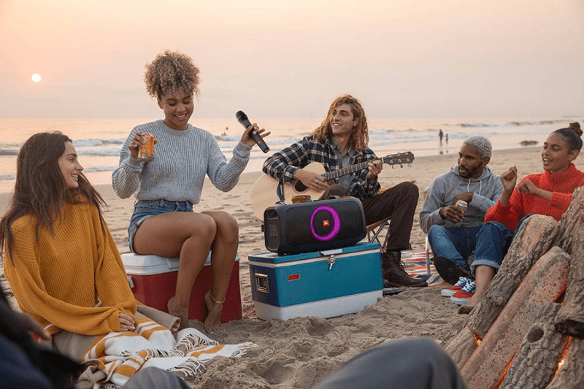

JBL Wireless Microphone combines with many portable karaoke speaker models everywhere.